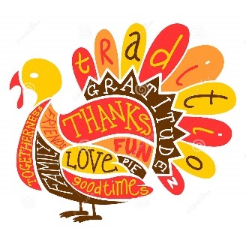
Thanksgiving for Homeless Veterans & Their Families
- We plan on feeding around 300 people
- Food drop off = 1436 King St., Cocoa, FL 32922
  - Hours: 8:00 am – 4 pm on Monday-Wednesday-Friday
- If you have any questions regarding frozen or thawed Turkey drop off please call our office at 321-208-7562
*** ALL DONATIONS NEED TO BE DELIVERED BY MONDAY NOV 20TH ***
WHAT WE NEED
-Turkey’s = 25 (WE NEED BY MONDAY 11/20 if they’re NOT cooked, must be thawed)
-Dinner Rolls = about 600 Complete!
-Already prepared fresh pies (bought or homemade) = 10
-Green Beans = 80 cans Complete!
-Cream of Mushroom Soup = 13 cans Complete!
-French Fried Onions = 25 Complete!
-Corn = 10 cans Complete!
-Cranberries= 34 cans Complete!
-Yams = 60 large cans Complete!
-Boxed Mashed Potatoes = 40 boxes Complete!
-Stuffing = 24 boxes Complete!
-Chicken Broth = 7 cartons Complete!
-Bottles of Turkey Gravy = 24 bottles
-Butter = 8-10 pounds Complete!
-Milk = 5 gallons Complete!
-Aluminum Foil = Extra Wide, 10 boxes
-Aluminum Trays = Giant 13 x 21, 30 Complete!
-Sandwich bags = small fold over, 350 Complete!
-Paper grocery bags = Large and Medium size, 200 each Complete!
-Cutlery Packets =150 each (Gordons Food Service Store) Complete!
-To-Go Containers = Large 100 Complete! and Small 116 (Pie) containers (Gordons Food Service Store)

